HARRIS PRIMARY SCHOOL  Be Kind • Be Thankful • Be Ambitious | Year 2 Newsletter  Autumn 2nd Half 2024 | 
Welcome to Year 2!

The children made a fantastic start to Year 2 last half-term. We have a very busy half-term coming up with preparations for our nativity play, a visit from the fire service and our Christmas fair.
I hope you find the information below helpful. Please feel free to contact the Year 2 team before or after school if you have any concerns or questions.
Miss Clayton
English  This half-term, we are reading a selection of traditional tales. This will prompt our reading and writing for the first three weeks of this half-term, working towards writing a fairytale with a twist.  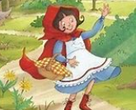 | Maths  We will begin this half term looking at measurement and shapes. Following that, we will practise our counting, multiplication and sorting skills. Year 2 will also be learning about statistics, fractions, money and time. | Science  We will be learning about how we grow and stay healthy in science.  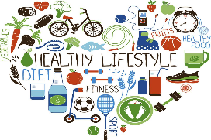
Guided Reading/Spelling/Phonics  The children will have Guided Reading for 30 minutes every day. They will work within an adult-led/supported group for two of the sessions. We will spend time reading a range of different books and texts, exploring vocabulary, making inferences and using evidence to support our thinking. The children will also have a 30-minute session every morning focusing on spellings and phonics. | Geography  We will be learning about India this half-term, making comparisons to our local area.   | Computing  We will be creating our own fairy tale stop motion animations using I Can Animate and LEGO.
DT  We will be thinking like engineers to design and build a new chair for Goldilocks!  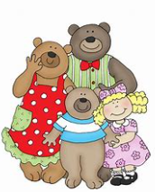 | PE  PE will take place on a Monday mornings where Mr Ridge will be focusing on dance and invasion games. | French  We will be learning the French names for animals.  
RE  This half-term's focus is Christianity: how do we respond to the things that really matter why do Christians say Jesus is the light of the world? | PSHE  Year 2 will be celebrating our unique character strengths to show how we can be the best we can be, as well as using Happy Breathing. The children will also have role play opportunities to equip them with the tools they need to solve issues they may face in and out of school, such as friendship problems and bullying. | Music  Our music will be delivered by Mr Baines on a Tuesday afternoon and we will be focusing on Musical Theatre.

Reminders
Creative – We will be getting messy and creative throughout the school year in subjects like art, DT and science. If you would like to bring in an old shirt for your child to wear during these activities, please bring them in and we can store them in the classroom to use as and when.

Names – Please remember to write/stick your child’s name on all their belongings, including water bottles (and for some children, socks!).

PE – Mr Ridge will be teaching the children PE skills on Monday mornings. This half term’s focus will be dance and invasion games. The children should come to school in their PE kit on Mondays.

Outdoor Learning – We will be doing some outdoor learning throughout the week, so the children should wear suitable clothes for being outdoors. We try to give the children outside playtimes in a range of weathers but, as the year goes on, the temperature (and overall weather) will be more variable.

Class Novel – We have started reading a selection of Grimm’s fairy tales this half-term. Every day the children will have the next part of the stories read to them and discuss interesting vocabulary from the chapter. Please encourage your child to tell you what has happened in the story that day. It will be a great way to recall what has been read to them.
Reading at Home  Please make sure you continue to read on a regular basis. This half term, your child’s reading books will get changed on the day that has been allocated for them. Our new reading records are for you to jot down what your child has read at home and any comments you would like to pass on. Your child will be heard by a member of staff in Year 2 at least twice a week.  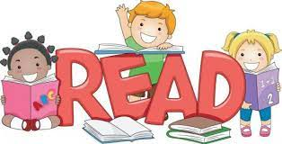 | Homework  A homework menu and spelling list will be sent home each half-term with instructions for the tasks and how to hand the homework in.  