HARRIS PRIMARY SCHOOL  Be Kind • Be Thankful • Be Ambitious | Year 2 Newsletter  Autumn Half-term 1, 2024 | 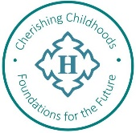
Welcome to Year 2!

I hope you have all had a lovely summer break and are looking forward to a busy and exciting year. It has been lovely to hear all about Year 2’s exciting adventures over the summer holidays and the children have already settled in well.
I hope you find the information below helpful. Please feel free to contact the Year 2 team before or after school if you have any concerns or questions.
Miss Clayton
English  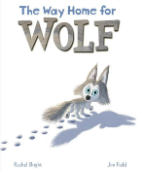  To begin Year 2, we will be reading The Way Home for Wolf as part of our English unit. This will prompt our reading and writing for this half-term, working towards writing our own story with an animal character that the children have carefully researched. We will also be using this research about our chosen animal to form an information page all about their habitat. | Maths    We will begin this half term looking at number, place value, addition and subtraction. Following that, we will explore different measurements and apply our knowledge of shape (2D and 3D), length, volume and capacity. | Science  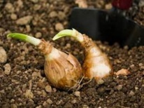  We will be planting seeds to observe and describe how they grow over time into mature plants. We will also be finding out and describing what plants need to stay healthy.
Guided Reading/Spelling/Phonics  The children will have Guided Reading for 20 minutes every day. They will work within an adult-led/supported group for two of the sessions. We will spend time reading a range of different books and texts, exploring vocabulary, making inferences and using evidence to support our thinking. The children will also have a 20-minute session every morning focusing on spellings and phonics. | 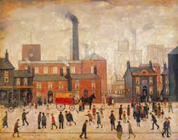  History  We will be learning about the cotton industry, how it changed Preston and the similarities and differences of people’s lives then compared to now. | Computing  We will be using the app ScratchJr. to program our own Knock, Knock jokes.  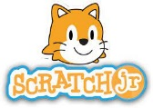
Art  We will be learning about the artist L.S Lowry and creating a piece of artwork in his style using pencil, chalk, oil pastels and ballpoint pens– focusing on the Cotton Mills from our History unit. | PE  PE will take place on a Monday morning where Mr Ridge will be focusing on games and gymnastics. | French  We will be learning the French names for animals.  
RE  This half-term's focus is Christianity: how do we respond to the things that really matter and does the way we treat the world matter?  We will retell the Christian creation story and discuss ways that we can look after our planet. | PSHE  Year 2 will be exploring what their brain looks like, how our brain works and how we can look after it, such as using Happy Breathing. The children will also have role play opportunities to equip them with the tools they need to solve issues they may face in and out of school, such as friendship problems and bullying. | Music  Our music will be delivered by Mr Baines on a Tuesday afternoon and we will be focusing on Pop music.

Reminders
Summer Diaries – If you kept a summer diary then we would love to see it. Please send them in so we can share them with the class.

Names – Please remember to write/stick your child’s name on all their belongings, including water bottles (and for some children, socks!).

PE – Mr Ridge will be teaching the children PE skills on Monday mornings. This half term’s focus will be games and gymnastics. The children should come to school in their PE kit on Mondays.

Outdoor Learning – We will be doing some outdoor learning throughout the week, so the children should wear suitable clothes for being outdoors (remember to check the weather forecast). We try to give the children outside playtimes in a range of weathers but, as the year goes on, the temperature (and overall weather) will be more variable.

Class Novel – We have started reading the story ‘The Legend of Kevin’ by Philip Reeve. Every day the children will have the next part of the story read to them and discuss interesting vocabulary from the chapter. Please encourage your child to tell you what has happened in the story that day. It will be a great way to recall what has been read to them.
Reading at Home  Please make sure you continue to read on a regular basis. This half term, your child’s reading books will get changed on the day that has been allocated for them. Our new reading records are for you to jot down what your child has read at home and any comments you would like to pass on. Your child will be heard by a member of staff in Year 2 at least twice a week.  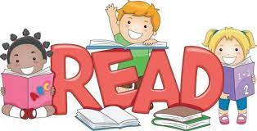 | Homework  A homework menu and spelling list will be sent home each half-term with instructions for the tasks and how to hand the homework in.  

